Verb Phrase

✅ Definition:
# Source: Chatgpt (GPT-4-turbo) at [7/28/2025]
A verb phrase is a group of words built around a main verb. It may include one or more auxiliary (helping) verbs, modals, negatives, and modifiers.
It functions as the predicate of a sentence, showing action or state of being.

🧩 Key Features of a Verb Phrase:
# Source: Chatgpt (GPT-4-turbo) at [7/28/2025]
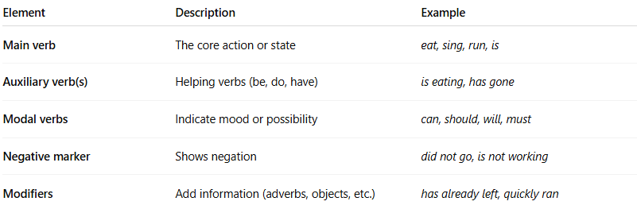
Element | Description | Example
Main verb | The core action or state | eat, sing, run, is
Auxiliary verb(s) | Helping verbs (be, do, have) | is eating, has gone
Modal verbs | Indicate mood or possibility | can, should, will, must
Negative marker | Shows negation | did not go, is not working
Modifiers | Add information (adverbs, objects, etc.) | has already left, quickly ran

✏️ Examples of Verb Phrases:
# Source: Chatgpt (GPT-4-turbo) at [7/28/2025]
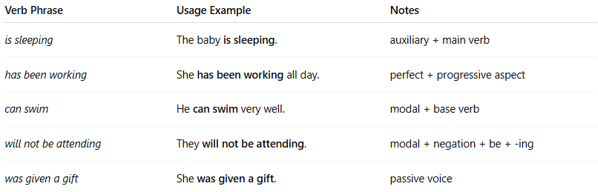
Verb Phrase | Usage Example | Notes
is sleeping | The baby is sleeping. | auxiliary + main verb
has been working | She has been working all day. | perfect + progressive aspect
can swim | He can swim very well. | modal + base verb
will not be attending | They will not be attending. | modal + negation + be + -ing
was given a gift | She was given a gift. | passive voice

🔧 Common Structures of Verb Phrases:
# Source: Chatgpt (GPT-4-turbo) at [7/28/2025]
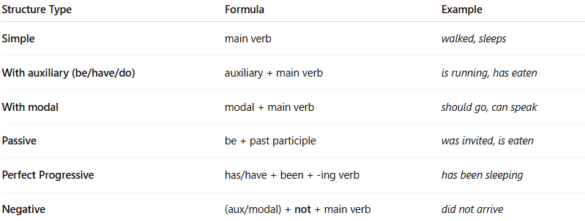
Structure Type | Formula | Example
Simple | main verb | walked, sleeps
With auxiliary (be/have/do) | auxiliary + main verb | is running, has eaten
With modal | modal + main verb | should go, can speak
Passive | be + past participle | was invited, is eaten
Perfect Progressive | has/have + been + -ing verb | has been sleeping
Negative | (aux/modal) + not + main verb | did not arrive

📌 Verb Phrases and Tense/Aspect/Voice:
# Source: Chatgpt (GPT-4-turbo) at [7/28/2025]
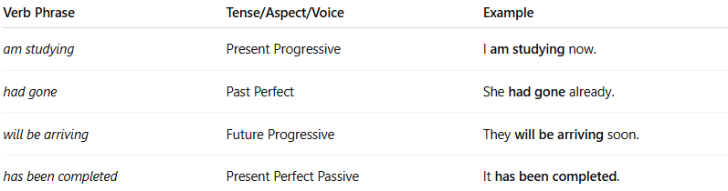
Verb Phrase | Tense/Aspect/Voice | Example
am studying | Present Progressive | I am studying now.
had gone | Past Perfect | She had gone already.
will be arriving | Future Progressive | They will be arriving soon.
has been completed | Present Perfect Passive | It has been completed.

🧠 Verb Phrase = Helping Verbs + Main Verb + (Modifiers)
# Source: Chatgpt (GPT-4-turbo) at [7/28/2025]
Example Sentence:
She might have been sleeping when I called.
- Verb Phrase: might have been sleeping
- Modal: might
- Helping Verbs: have been
- Main Verb: sleeping

🧠 Summary Table
# Source: Chatgpt (GPT-4-turbo) at [7/28/2025]
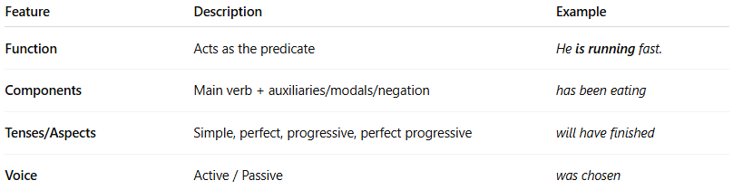
Feature | Description | Example
Function | Acts as the predicate | He is running fast.
Components | Main verb + auxiliaries/modals/negation | has been eating
Tenses/Aspects | Simple, perfect, progressive, perfect progressive | will have finished
Voice | Active / Passive | was chosen

